Alaaf,
What a madness today! Sausages, cheese and lemonade… Music that echoed through the school all day long and the “longest polonaise in the world” with all 35 classes in the entire building!
It’s such a joy to see all the children so happy and dressed up so nicely! And it already started yesterday with the final performances of the group 1-2 circus and the pyjama day.
The toddlers have practiced and worked hard and learned many new words and tricks. How exciting to perform for the (parents, grandpa’s and grandma’s) audience. They all did great!
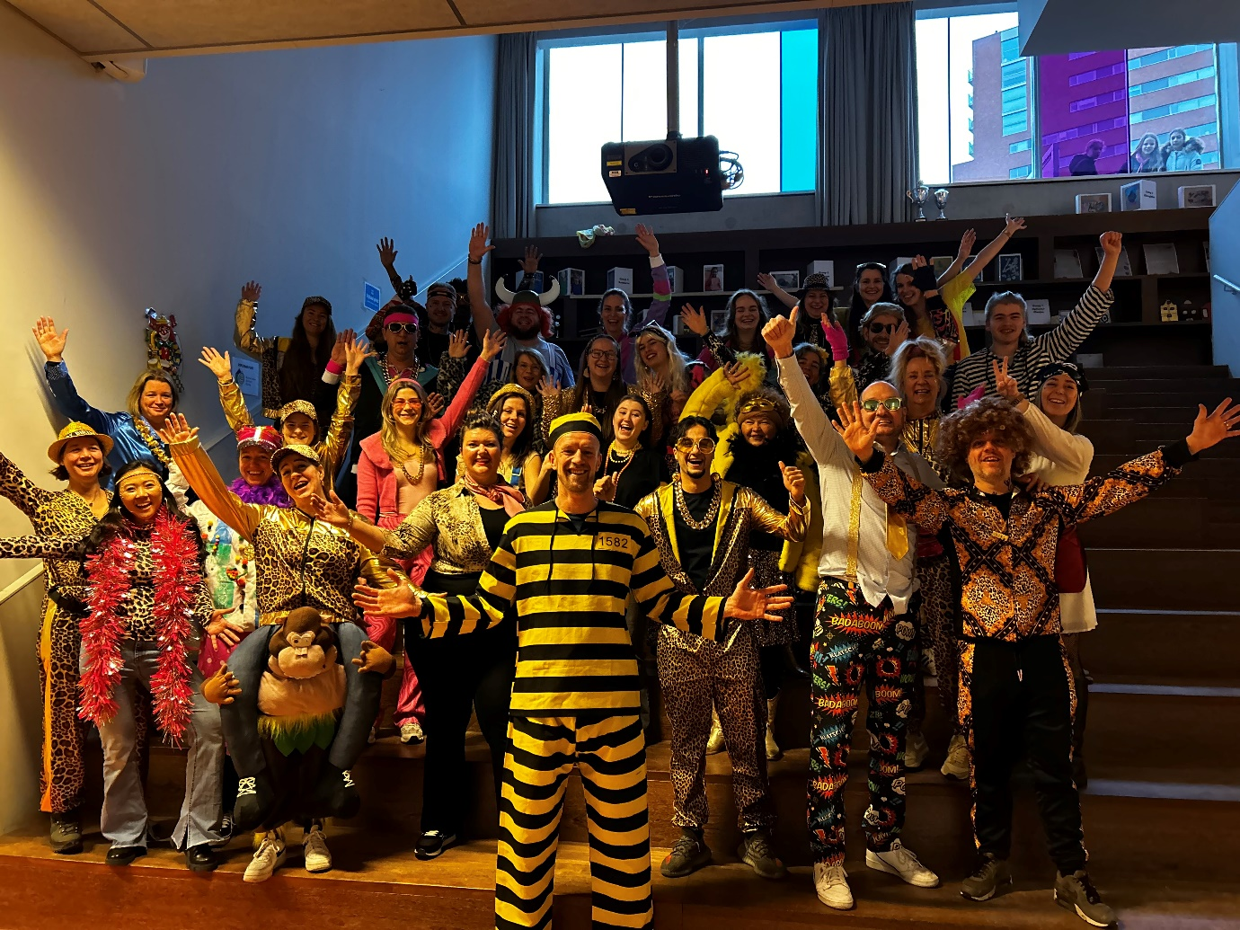
On behalf of Team St@rtbaan we wish you a happy Spring Holiday!

Calendar
February 16th | School reports go home; Circus performance for (grand-)parents by the toddler groups
February 17th | Carnavals in the morning  Out of school at 12:30 pm
February 20-24th | Spring Holiday
February 27th | Groups 5-6: author Michael Reefs visits the St@rtbaan  OR Meeting
February 28th | Language-at-home Day groups 1-8
March 2nd | Group 4: Start of MuziekKoning (“King of Music”) Ruud; music workshops

Language-at-home Day
On Tuesday, February 28th, we will pay attention to the Language-at-home Day at school. Together with the children, we reflect on the diversity of languages in our school. For this we ask you to make a flag, which the children will receive from school on Monday February 27th, together with your son or daughter and to return it on Tuesday. On this day, the teachers make a beautiful garland of the flags, which will be talked about with the children. By preserving the mother tongue, the linguistic and cultural tradition is preserved and we all become more aware of the differences between the various groups of people. This will lead to more understanding. In addition, it contributes to the sense of self-esteem for every child.

Welcome at the Parent Lounge
On March 1st we will start with the Parent Lounge! Every Wednesday from 8:30 to 10:00 am the Parent Lounge will take place in the school canteen / teacher room.
At the Parent Lounge we welcome all parents to meet and talk about issues such as raising, parenting and all other matters that concern us as parents. Together we determine what we will talk about. The Omnia Pedagogical Support Officer is present for guidance and advice to all questions concerning raising, parenting and everything related to this. Ask your question and join the conversation! Feel welcome and join us on March 1st for a cup of coffee or tea and something delicious.

Jacques Vriens at the St@rtbaan
On Thursday February 9th, we had a visit from children’s book writer Jacques Vriens for all children of groups 3 and 4. He showed how you can invent and create stories. Additionally he read from his new book: ‘Into The Wide World’. The children were able to ask many questions. What a party for the children and their teachers.
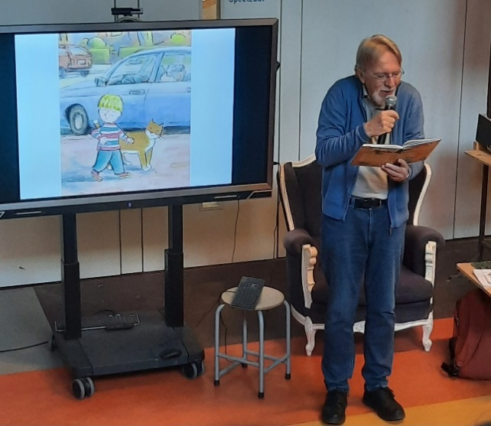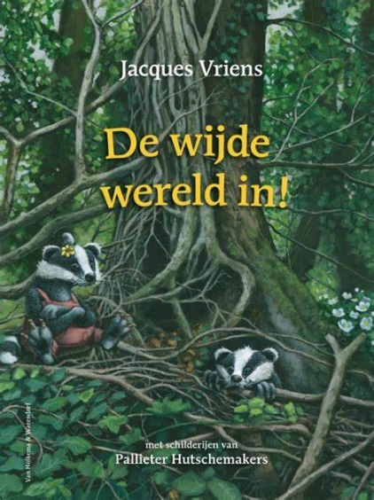

Liz goes to her next school
Today is Liz’ last day at the St@rtbaan. She will start at the Berkenschutse after the Spring Holiday. To all colleagues who have cared for her in this period of time: thank you so much for your help, attention, love, patience and commitment. This shows our big heart for our children here at our school. From Team St@rtbaan we also thank the cooperation with parents and all agencies involved. We wish Liz lots of fun at her new school.
Below shows the photo of when she was allowed to come back to us again and now she is already entering the next phase.
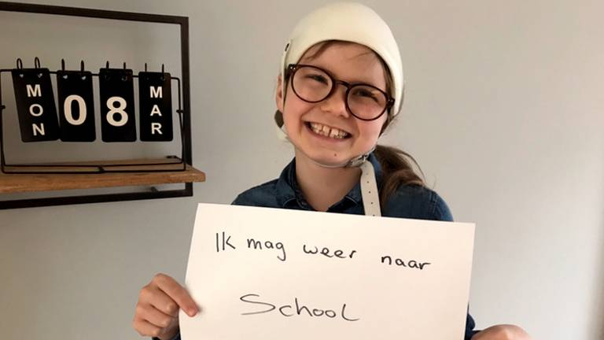

Letter from MuziekKoning Ruud
Hello 4th grade lackeys,
From Thursday March 2nd I will be back on the St@rtbaan for six times.
Each Thursday I bring musical instruments!
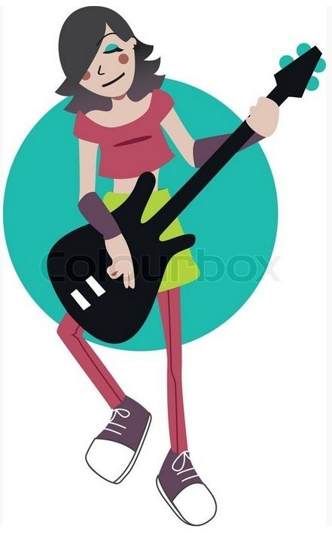
Then we will make music, sing the St@rtbaan Blues and the Instrument Song. You will learn everything about all kinds of instruments, music from different countries, film music and we will do a music quiz.
And the best part is of course that you can play the instruments! The last time, April 13th, we will perform for mom and dad, grandpa, grandma, brother, sister….
And if you already play an instrument, you can always bring it with you if you wish.
Okay, see you in a few weeks. I’m excited. Let’s make a music party!
Greetings from MuziekKoning Ruud

Attachments:
- Chess tournament Eindhoven (NL/ENG)
- Leergeld Foundation Flyer (NL/ENG)

On behalf of Team St@rtbaan

HAPPY HOLIDAYS!

