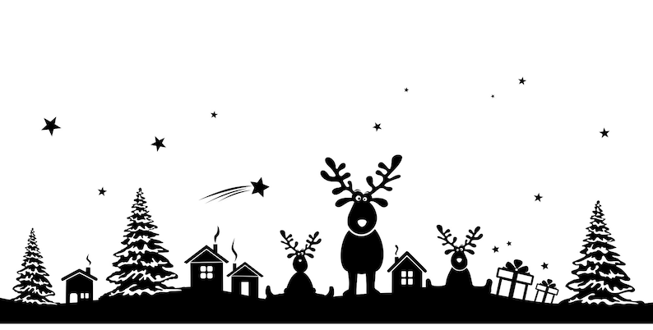
Christmas 2022

We have listed a number of important things for you:

Christmas wish tree / Christmas letterbox
- Parent(s)/carer(s) and children can hang a wish in the Christmas wish tree near the grand stairs. This way we want to keep the Christmas spirit alive. This is possible from December 8.
- From December 8, the Christmas letterbox will be back in school on the first floor. Mail can be sent to the children. Write the child’s name and class on the card so that the mail arrives properly.
Christmas dinner (December 22)
- On Thursday December 22 we will have a Christmas dinner in all classrooms. This means that all children will prepare either a starter, main course or dessert for 5-7 children. These dishes will be presented in a buffet.
- From December 16, you or your child can indicate which dish your child is making on the registration sheet at the door of the classroom, so that there is variety in the food. There will also be an allergy list at the door of the classroom.
- On Wednesday December 21 or Thursday morning December 22, each child brings a plate, cutlery and a cup in a plastic bag, labeled with her own name.
- We hold a short walk-in from 5:45 PM to 6:00 PM. Parents as well as children come in and prepare the dishes. Christmas dinner is then from 6:00 PM to 7:30 PM. You can pick up your child from the classroom at 7:30 PM. If you wish to make other arrangements with your child, please inform the teacher.

During the children's Christmas dinner, a cozy parent's drink will be organized under the hangar. You are welcome to join! Please sign up for this via the Parro app.
On behalf of the entire team, we wish you happy holidays!

